7.75: a)
so 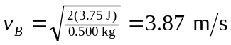, or 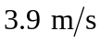 to two figures. b) At this point (point C), 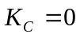, and so 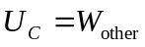 and 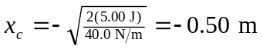 (the minus sign denotes a displacement to the left in Fig. (7.65)), which is 0.10 m from the wall.

